AI CHATBOT
1. ABSTRACT
Customer support systems often require significant human intervention to respond to user queries. This leads to delays, increased workload on support staff, and inconsistent responses. With the advancement of Artificial Intelligence and Natural Language Processing (NLP), chatbots have become an efficient solution to automate customer interaction.
This project aims to design and develop an AI chatbot using Python and Flask that can understand user queries, generate automated responses, and provide real-time assistance. The chatbot supports FAQ answering, order tracking examples, appointment booking prompts, and API integration for real-time information such as weather and live data. The proposed chatbot can be used across industries like e-commerce, banking, healthcare, and education to improve customer engagement.
The chatbot uses rule-based logic combined with AI-generated responses. The Flask framework is used as the backend, while HTML/CSS/JavaScript is used for the front-end chatbot interface. The system is lightweight, user-friendly, and easily deployable.
2. INTRODUCTION
A chatbot is a conversational AI program that interacts with users through text. Modern chatbots simulate real human conversation and can handle tasks such as:
- answering frequently asked questions
- providing instant support
- guiding users through processes
- fetching live information using APIs
Companies such as Amazon, Swiggy, Flipkart, banking websites, and hospitals use chatbots to:
- reduce workload on customer support teams
- provide 24×7 assistance
- improve customer satisfaction
- minimize response time
This project implements such a chatbot with:
- Flask backend
- web-based chat interface
- predefined rule-based replies
- AI-generated responses
- API integration
3. OBJECTIVES
The objectives of the project are:
- To design and develop an AI-based chatbot system
- To understand and respond to users’ queries automatically
- To support FAQ-based and AI-generated answers
- To provide real-time information using APIs
- To deploy chatbot on a Flask web framework
- To create a simple and user-friendly chat interface
4. PROBLEM STATEMENT
Traditional customer support systems rely heavily on:
- manual answering
- delayed responses
- availability of staff
This causes:
- long waiting times
- repetitive questions burdening agents
- higher operational costs
Therefore, there is a need for an automated chatbot system that can:
- respond instantly
- handle multiple users simultaneously
- integrate with APIs for real-time information
- assist human agents by resolving common queries automatically
5.LITERATURE REVIEW
Previous research and implementations of AI chatbots demonstrate that Natural Language Processing (NLP) plays a major role in improving the efficiency and accuracy of responses in customer support systems. Studies show that rule-based chatbots are highly effective for answering frequently asked questions, where responses follow predefined patterns and limited variations. However, with the introduction of advanced AI language models such as GPT and BERT, chatbots have gained the ability to understand context, manage complex conversations, and generate human-like responses. Flask has also been widely used in academic and industrial work as a lightweight yet powerful web framework that enables easy deployment of chatbot applications. Furthermore, integrating third-party APIs—such as order tracking, weather, banking, or booking services—significantly enhances the functionality and real-time usefulness of chatbots. Existing platforms such as Google Dialogflow, IBM Watson Assistant, and Microsoft Bot Framework further validate the effectiveness of AI-driven conversational systems by providing scalable, enterprise-level solutions that have been successfully implemented across domains like e-commerce, healthcare, and banking However, they are paid/complex.
Hence, an open-source Python Flask chatbot is developed in this project.
6. SYSTEM REQUIREMENTS
Hardware Requirements
- PC / Laptop
- 4GB RAM or higher
- Internet connection for APIs (optional)
Software Requirements
- Python 3.x
- Flask
- HTML, CSS, JavaScript
- IDE: VS Code / PyCharm
- Browser: Chrome / Edge
7. SYSTEM ARCHITECTURE
User → Web Interface → Flask Server → NLP/Rules/AI → Response Generated → Sent to User
When using API integration:
User query → Flask → External API → Data fetched → Response returned
8. METHODOLOGY
The steps followed in implementation:
- Requirement analysis
- Designing chatbot conversation flow
- Creating Flask backend
- Developing web frontend UI
- Implementing rule-based responses
- Adding NLP enhancements
- Integrating APIs (weather, dummy order tracking, etc.)
- Testing with different user queries
- Deployment and documentation
9. IMPLEMENTATION DETAILS
The chatbot supports:
✔ Greetings recognition
✔ FAQ replies
✔ Order tracking prompts
✔ Refund queries
✔ Appointment scheduling replies
✔ API-based answers (e.g., weather/live info)
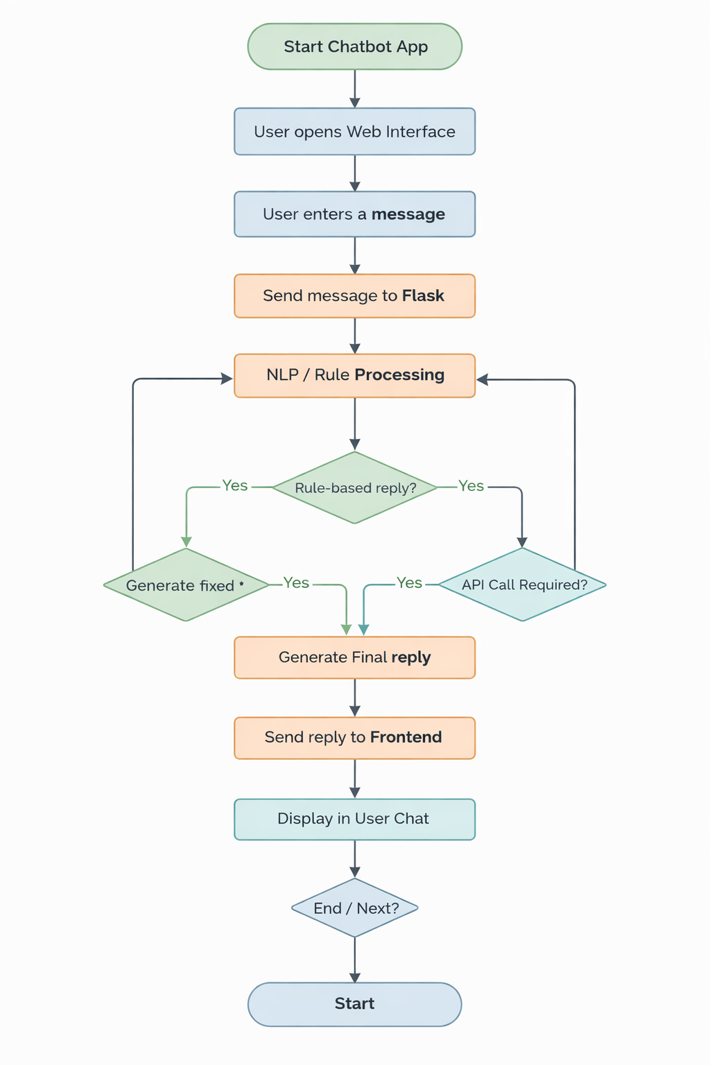

10. API INTEGRATION DETAILS
Examples of integrated APIs:
- Weather API
- Order status mock API
- News API
- Currency conversion API
Process:
- User asks: “What is today’s weather?”
- Flask receives request
- Flask calls external API
- API returns JSON data
- Chatbot formats and displays answer
11. APPLICATIONS
This chatbot system can be used in:
- E-commerce customer support
- Banking help-desk
- Railway/information system
- Healthcare appointment scheduling
- College enquiry bots
- Telecom service bots
- Hotel booking systems
12. ADVANTAGES
- Instant automated response
- 24×7 availability
- Reduces human workload
- Consistent answers
- Scalable and customizable
- Cost-effective system
13. LIMITATIONS
- Handles limited intents (expandable)
- Accuracy depends on rule design
- Internet required for live APIs
- Not fully emotionally intelligent
14. FUTURE ENHANCEMENTS
- Speech-to-text chatbot
- WhatsApp / Telegram chatbot
- Deep learning based NLP model
- Multi-language support
- Voice assistant integration
- Database knowledge base learning
- Sentiment analysis features
15. CONCLUSION
The AI chatbot developed in this project demonstrates how Artificial Intelligence and Flask web technology can be combined to build an efficient and interactive support system. The chatbot successfully automates responses, answers frequently asked questions, and retrieves real-time information using APIs.
This reduces manual effort, improves service quality, and enhances user experience. With further integration of advanced NLP, the system can be scaled into an enterprise-level intelligent assistant.
16. REFERENCES
- Flask Web Development – Miguel Grinberg
- Jurafsky & Martin, Speech and Language Processing
- Python Official Documentation
- Chatbot Research Papers (IEEE & Springer)
- API Provider Documentation
- NLP Textbook resources

